AI ASSISTED CODING
ASSINGMENT-2
NAME:K.POORNACHANDER
HALL.NUMBER:2403A52382
BATCH:AI 14
Task Description#1
- Use Gemini in Colab to write a function that filters out all negative numbers from a given list.
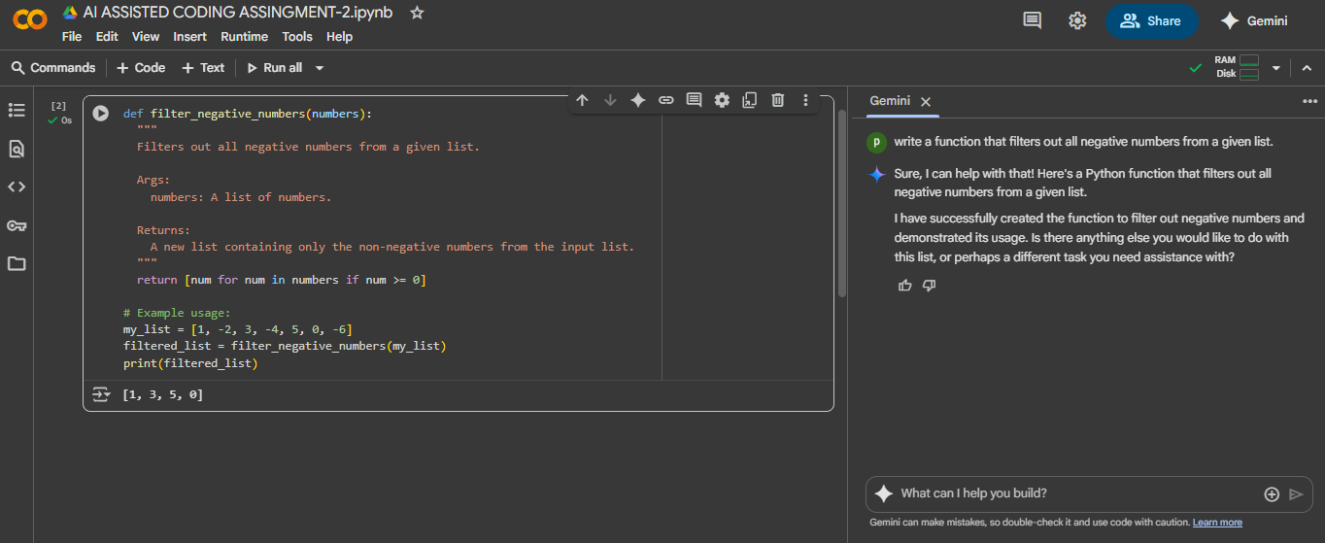

EXPLANITION: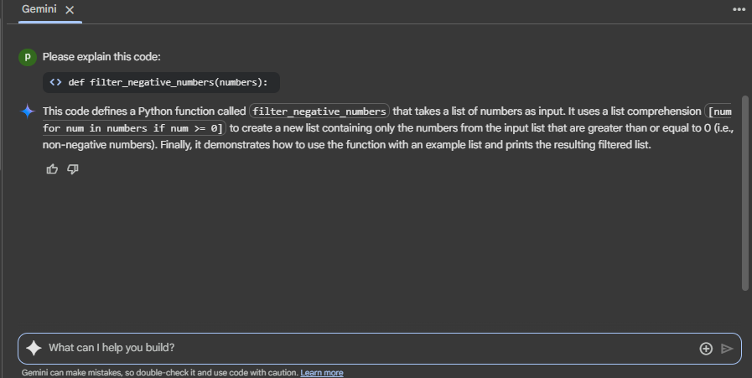
Task Description#2
Ask Gemini to generate code that reads a text file and counts the frequency of each word. Then ask it to explain the code.
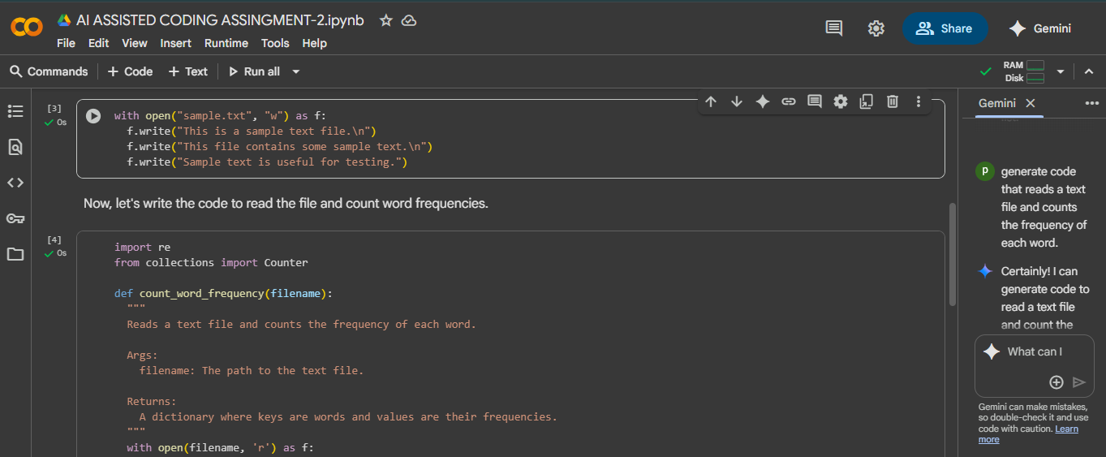
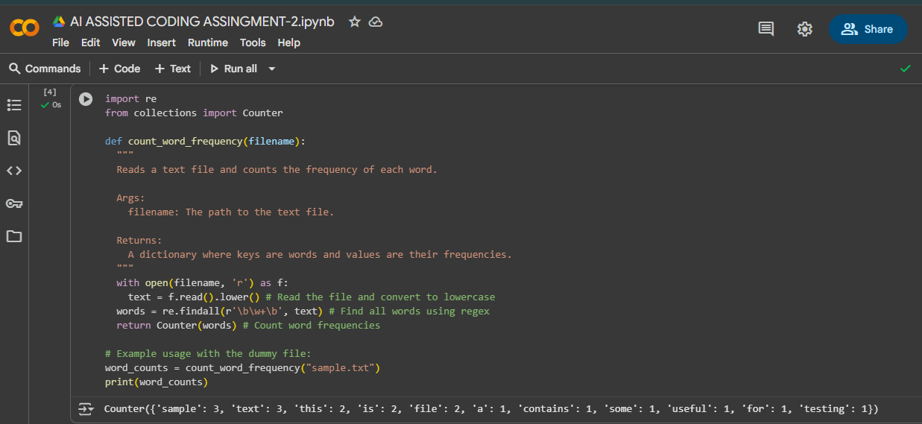
EXPLANITION:
